Lab 2

Part 1

This part a continuation of lab 1. Please use the standard answer of Lab 1 as the starting point.

Step 1: Fill in the following information about Students and Enrollments:
- Nuno Bloggs (156123) studies HSB and HCI-101. His email is nuno@bloggs.com.
- John Trump (156897) studies HSB, MC1, MC2. His email is John@trump.com.
- Lidia Elliott (123987) studies no modules at present. Her email is Lidia@gmail.com.
- Alicia Smith (777123) studies MC2. Her email address is Alicia123@456.com.
- Sophie Johns (127845) studies HSB, HCI-101, MC1 and MC2. Her email address is S.Johns@nott.edu.cn.

Step 2: Write the necessary SELECT SQL to obtain the answers to the following queries:
- Print the Names of all Teachers.
- Retrieve all students and all of the information held about them (excluding enrolment).
- Retrieve the student ID’s who study MC2.
- Retrieve the list of student ID’s, names and email address for students who study HCI-101. Your results should not include duplicates or incorrect information.
- Retrieve the Names of students who do not take the module ‘MC1’
- Retrieve the Names and Emails of students who study both ‘MC1’ and ‘MC2’.
- Retrieve the Names and Telephone Numbers of lecturers whose office is in the ‘BES’ building.
- Retrieve the IDs of students who take the module 'MC1' OR 'MC2'.
- Retrieve the Names and Emails of students who study either in 'MC1' OR 'MC2'.
- Retrieve the Names and Emails of students whose email is not ended with '@gmail.com'.
- Identify if there is any student who enrolled in HSB, HCI-101 and MC2 and Retrieve the Names and ID of them.
- Retrieve the ID and Names of students whose name includes 'ia'.
- Retrieve the Names and Emails of students who does not study 'MC1' OR 'MC2' OR 'HCI-101'.

Part 2 - Homework

- Please complete this part by hand
- This isn’t an assignment and is thus not marked.
- Finish it and bring your questions to the lab in the next week.

Task 1

Given table T shown below:
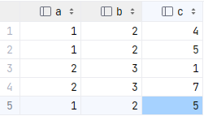

Calculate the result of the following SELECT statements, note that the order of tuples does not matter in this task:
- SELECT DISTINCT a, b FROM T;
- SELECT DISTINCT b, c - a FROM T;
- SELECT DISTINCT a + b, c - a FROM T;
- SELECT c - a - b AS j FROM T WHERE c - 1 >= (a + b);
- SELECT c FROM T WHERE a * 2 > b AND (c < b);
- SELECT * FROM T WHERE (a, b) <> (1, 2) AND (b, c) <> (3, 1);

What does the highlighted expression do?

Task 2

Given table T shown below:
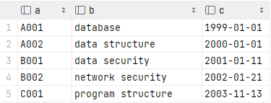

Calculate the result generated by the following SELECT statements, note that the order of tuples does not matter in this task:
- SELECT * FROM T WHERE a = 'A001' OR a LIKE 'B001';
- SELECT * FROM T WHERE a NOT LIKE 'A%' AND b LIKE '_security';
- SELECT * FROM T WHERE a NOT LIKE 'A%' AND b LIKE '%security%';
- SELECT * FROM T WHERE a LIKE '_001' AND b LIKE '%_s%';
- SELECT * FROM T WHERE (a LIKE 'B%' OR a LIKE '___1') AND c < '2002-01-01';
- SELECT * FROM T WHERE (a LIKE 'B%' OR a LIKE '___1') AND c LIKE '%-01-%';

Task 3

Given tables “books” and “authors_of_books” shown below:

books
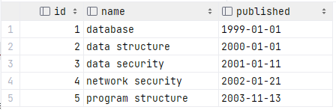

authors_of_books
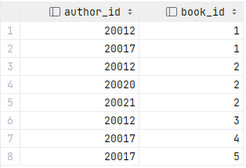

Build these tables using the script below:

DROP TABLE IF EXISTS books, authors_of_books;
CREATE TABLE books (id INT, name VARCHAR(20), published DATE);
CREATE TABLE authors_of_books (author_id INT, book_id INT);
Q1: This question tries to test your understanding of the current data in these two tables: How many authors does each book have? The answer is obvious. If in doubt, ask any teaching assistants nearby.

Q2: Calculate the result generated by the following SELECT statements, note that the order of tuples does not matter in this task:
- SELECT author_id, name FROM books, authors_of_books
WHERE books.id = authors_of_books.book_id AND published < '2001-01-01';
- SELECT DISTINCT id FROM books, authors_of_books
WHERE books.id = authors_of_books.book_id * 2;
- SELECT b1.id FROM books b1, books b2
WHERE b1.id < b2.id AND b2.name LIKE 'data%';
- SELECT name
FROM
(SELECT * FROM books WHERE books.id < 4) b,
(SELECT * FROM authors_of_books WHERE author_id < 20020) t
WHERE
b.id = t.book_id;
- SELECT * FROM books WHERE
id IN ( SELECT book_id FROM authors_of_books
WHERE author_id IN (20012, 20021) );
- SELECT * FROM books WHERE
id IN ( SELECT book_id FROM authors_of_books
WHERE author_id < 20020 and author_id > 20013 );
- SELECT * FROM books b1 WHERE
EXISTS ( SELECT book_id FROM authors_of_books
WHERE book_id = b1.id * 2 ); -- hard

